**Lovely professional university**

**Final report**

**Submitted by :**

**Name reg no**

S.Yashita reddy 11905712

M.Chandu 11903391

B.Om Meher 11904538

**Submitted to :**

**Dipen saini**

Introduction:

In this project we have to design a website for income tax department .In these it includes about us ,feedback,e-accessibility and contact us in one frame and heading as important news in another frame and then our website includes about login details forgot password ,submit and reset etc., and in another frame some text regarding income tax and in the last frame we have given some links and FAQ’s.Totally five frames are there in our page.All are going to explain about income tax department etc.

There are totally 5 frames and we named them as frame 1,frame 2,frame a,frame b,frame c.

We have written different codes in different pages for these 5 frames and then in another notepad .We have stored the address of this 5 frames codes and by executing the last code in which all the address of codes of frame will be executed to get our output .

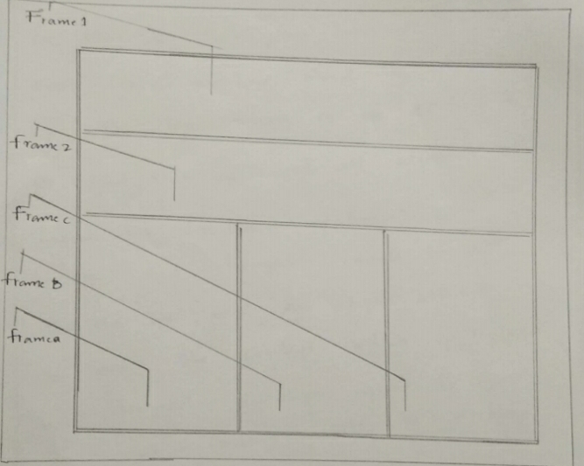

**Frame 1:**

In this we have given table width as 8% and then we have stored the address of the logo which is in drive in pc.And then we used all attribute for income tax department of india with width and height equals to 100.And the we used a lighten attribute to set the content which we required .We assigned div align equals to right .So, our content will be displayed right side of the frame .The contents are contact us ,E-accessibility ,feedback and about us.And the input type for them is button with this we have created our frame 1 successfully.

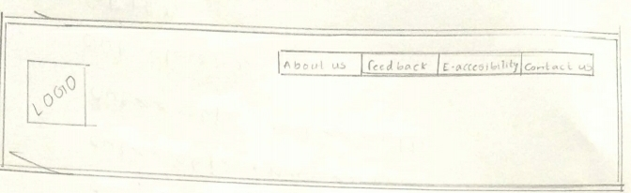

**Output of frame 1:**

**Frame 2:**

In this we have given table division width as 8%.And then we used marquee vspace attribute .This attribute used to set the vertical margin. The given value is used to set the space between the marquee element and other contents .

Syntax:-

<marquees vspace =”px”>

Attribute :px specify vertical space around marquee.

For the text “important news” we have given marquee vspace is equal to 3% with this we have completed our frame 2.In this for “important news” we have used <u> and <b>tag<u>attribute tag represents some text should be stylistically different from normal text .Such as mispelled words or proper nouns in chines and <b>tag is to represent the text in bold form .So,that “important news ” in frame 2 is executed with

bold letters and stylistically different from other text

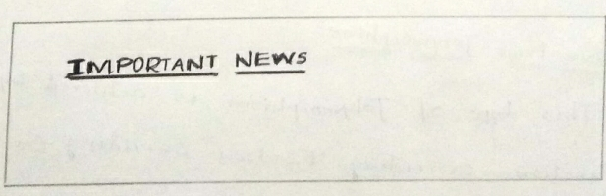

Output of frame 2.

**Frame a:**

In frame a we given body align as “center ” .So, that all the content given by us will be at center firstly ,login we have given a tag <b> to it .So, that letters will be bold .And then it is the form name actually form name is equals to login form and method is past and for tablets to enter data we have given width as 20% and alignment is at center .

And them we went to next row by choosing the tablet rows and division .Input type is text and size is 25 ,name is “user id ”,place holder is username this will be filled in table division of a single row.And similar in next row for password input type is password ,size =25 and name is pwd,place holder is password.And we have written code for submit ,reset onclick they are going to be action and we also created for forgot password with this frame a is finished .

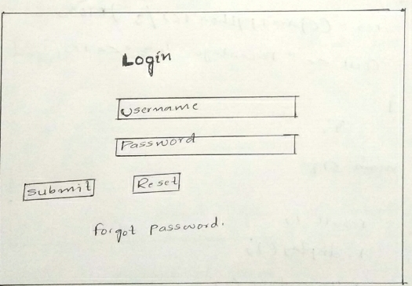

**Frame b:**

In these we are displacing some paragraph about income tax department with the title news and updates with a tag <b> and then paragraprh with these frame b is also done .

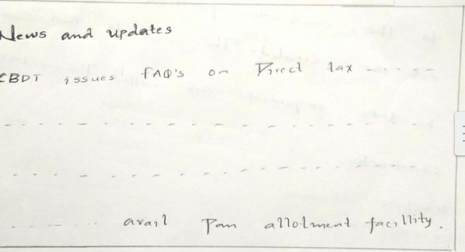

**Frame c:**

In frame c we have given some quick links .To create a link in html.href(hypertext reference )is used. The href is an attribute of the anchor tag ,which is also used to identify sections within a document and we have written four links for instant e-pan ,link Aadhaar ,submit forms and &TR status .And for FAQ’s about what is income tax with this frame c is also done successfully.

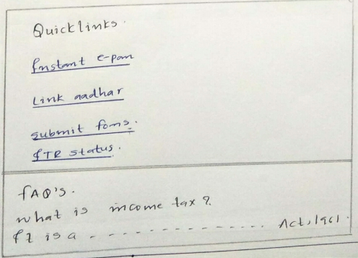

Output of frame c.

**Complete setting of all frames :**

And we saved codes for alla frames in D-drive and in another notepad and title is income tax department of India. The rows attribute specifies the size of and the number of rows in a <frame set >.Each frame is height is specified in the rows attribute in a comma -separated list .Note :The number of rows attribute values specified ,defined the number of rows in the <frame set > and frame set rows we assigned are 20% ,ma 20% and then we have given all the addresses of frames and then by executing .we got our webpage .

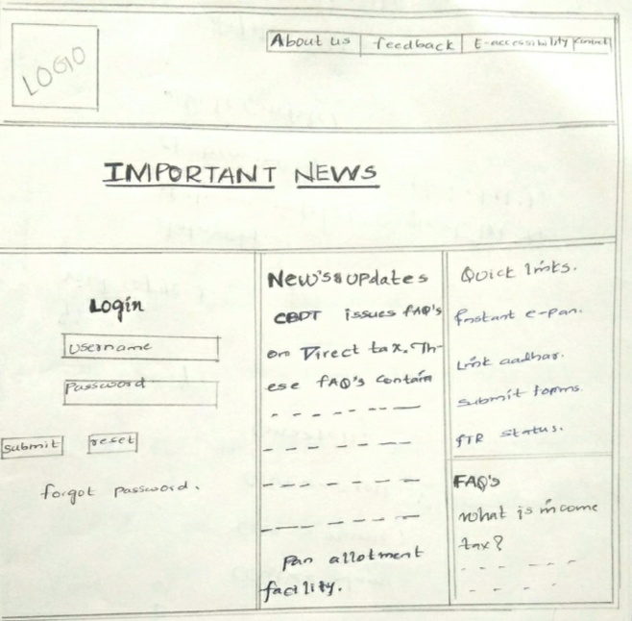

**Conclusion:**

Within this task we got to know about how to create webpage etc.At before we are having only therotical knowledge on designing now we are having both practical and theoretical knowledge ,with this project practical knowledge is developed much for this project we are three members to do we divided our tasks for completion of project in time .

**Acknowledgement:**

In completion of this project we have to help from our senior and our faculty ,and our faculty helped us on gaining knowledge .And we specially thank our senior they shared their knowledge to us and help from google also.

Website is w3school.com.In this website we got to know about many things .And by taking helps from these resources and had done our work in time .